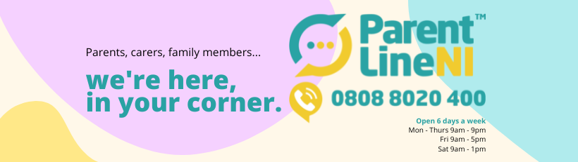

Next week marks the most important week in our calendar – Parenting Week! From Monday 17th – Friday 21st October we will be sharing our messaging with one main aim – Appreciating and Valuing Parents. We are launching a brand new animation sharing our service, which we are excited about!

We have put together this social media asset pack to allow individuals and organisations to get involved on their own channels during the week by scheduling in these curated posts to their own channels.

Please take a few moments to post one or more of the below posts during Parenting Week. They can be copied and pasted directly on to Twitter, Facebook and Instagram. To add the accompanying picture, just save this document to the device you are on, then right click on the photo to save it, and then add it to the post as you would a photo on Facebook for example. We would really appreciate your help on sharing our messaging this Parenting Week 2022.

Please don’t post anything before Monday, as we aren’t launching our new animation until then! Thanks.

In addition to our posts, if you are creating any of your own content to mark Parenting Week, please do tag us and we will make sure to share.

Our social media handles:
Facebook: @parentlineni
Twitter: @childreninNI
Instagram: @parentline.ni

Post 1:

This Parenting Week 2022, Parentline NI remind parents, carers and family members they are here and #inyourcorner. Whatever you are facing as a parent, Parentline are here to listen, support and guide you. We have no waiting lists and are here for your call. #parentingweek

Picture to go with post:

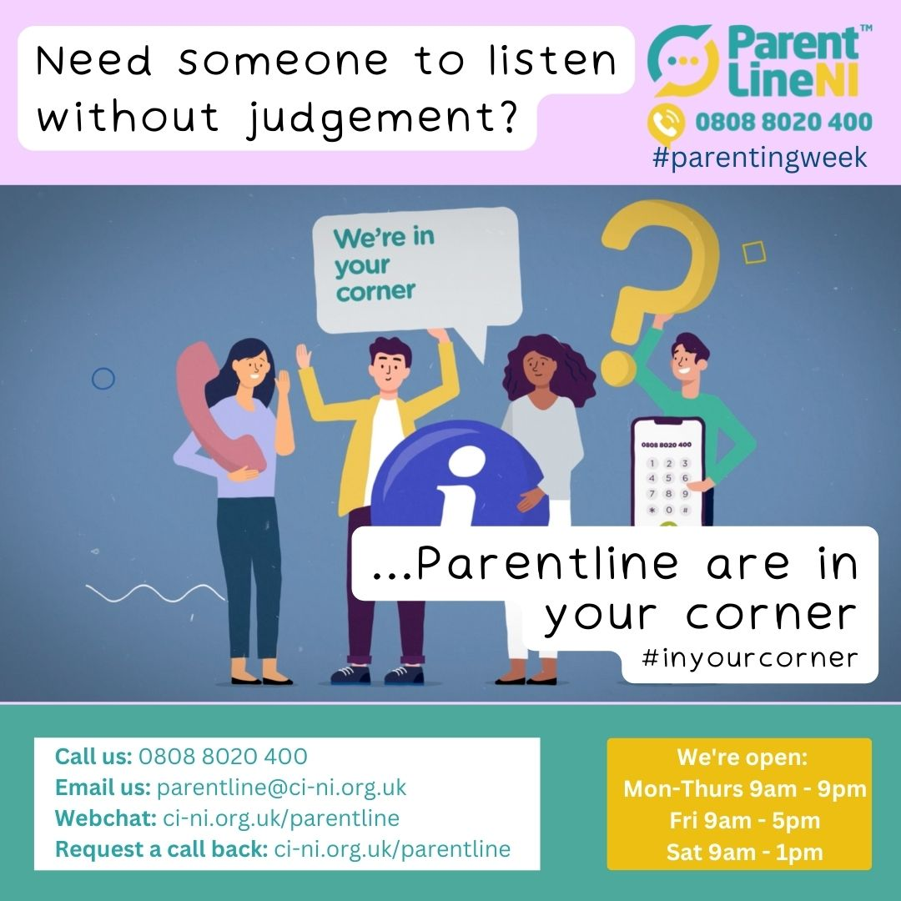

Post 2:

This Parenting Week, Parentline NI are launching a new animation sharing exactly how Parentline can support YOU. Check it out here https://youtu.be/9mqSWgPQGNs
#parentingweek

Picture to go with post:
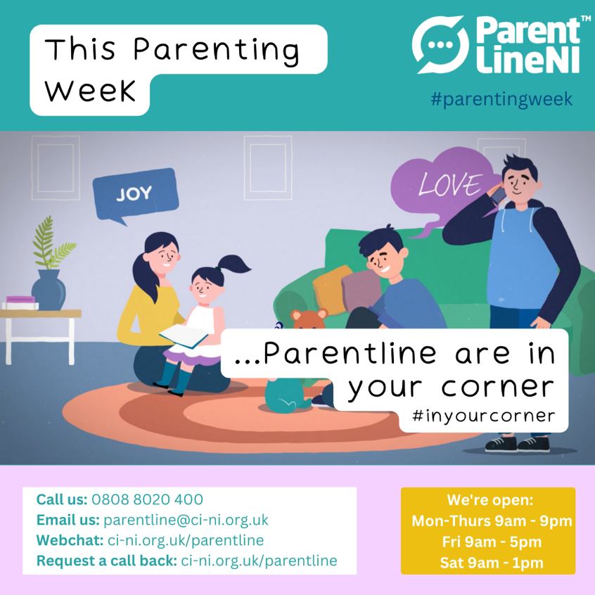

Post 3:
We know it can be a big step to reach out and look for support especially if you are feeling overwhelmed and overloaded. Parentline NI are on the phone, webchat, or email to support you. You can also request us to call you back via our website https://www.ci-ni.org.uk/parentline/. Parentline is here to listen, a space to feel heard, find solutions and here to support you take a step forward today. #parentingweek

Picture to go with post:
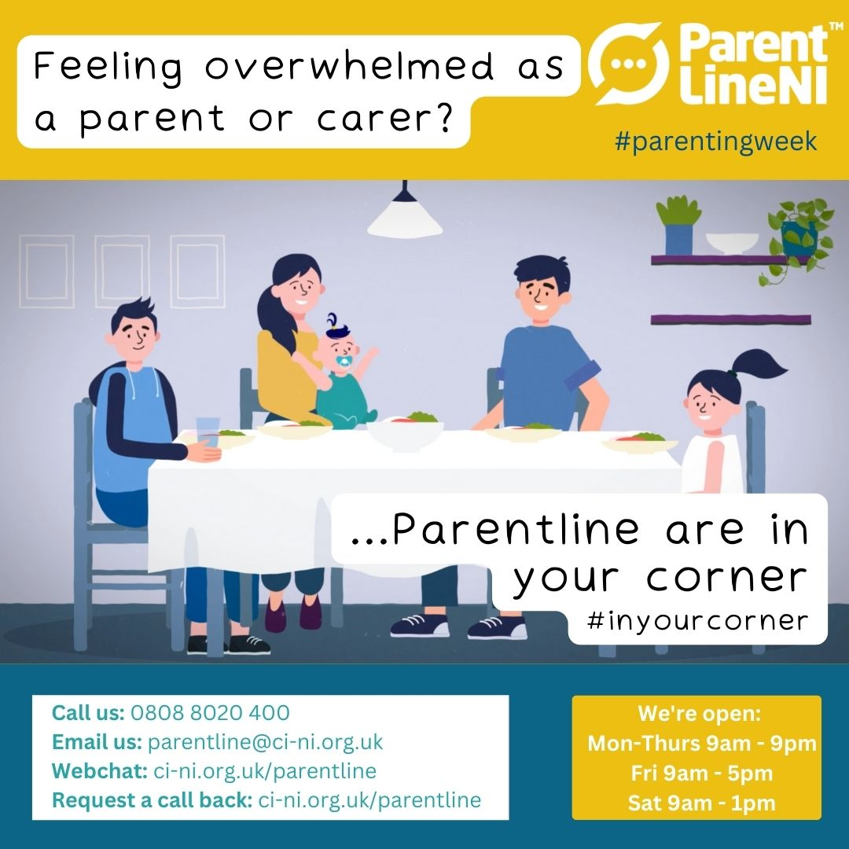

Post 4:
Do you work with parents or families? This #parentingweek, ParentlineNI are #inyourcorner and supporting parents together. The Parentline website has a bank full of resources available now to download and print as well as information on Parentline services and making referrals. Check out https://www.ci-ni.org.uk/parentline/ or call today on 0808 8020 400. Supporting parents together.

Pictures to go with post: (one or more can be used)
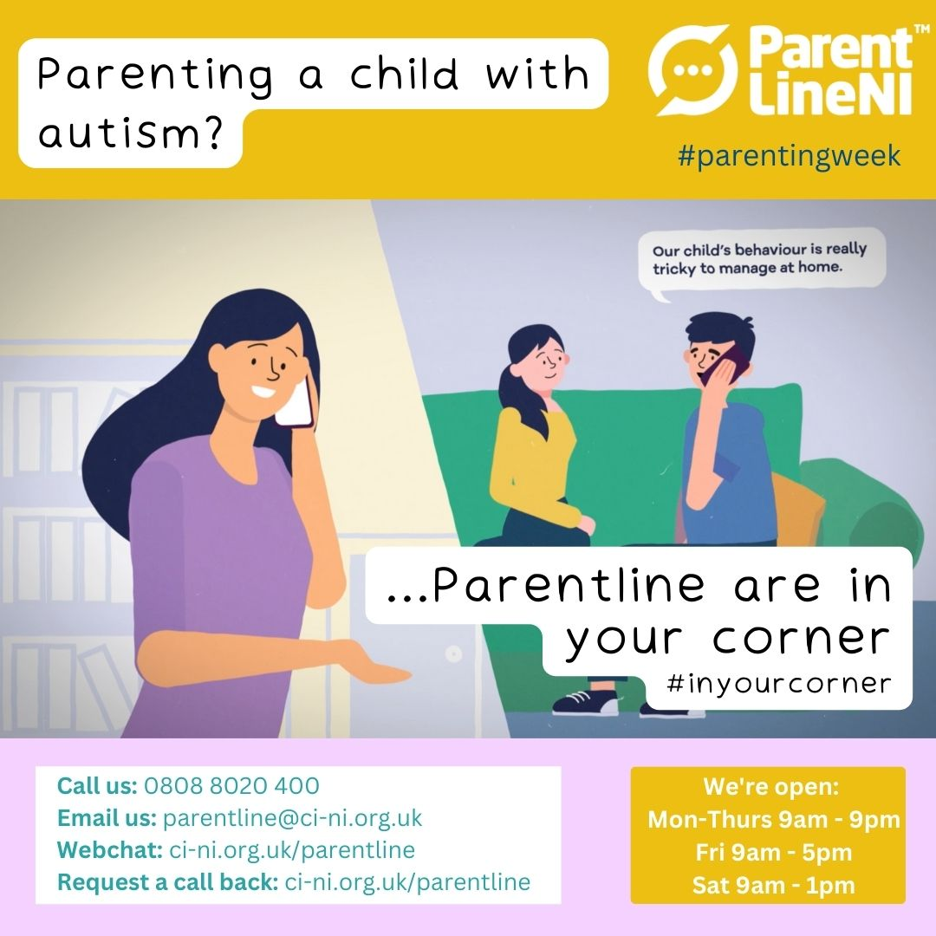

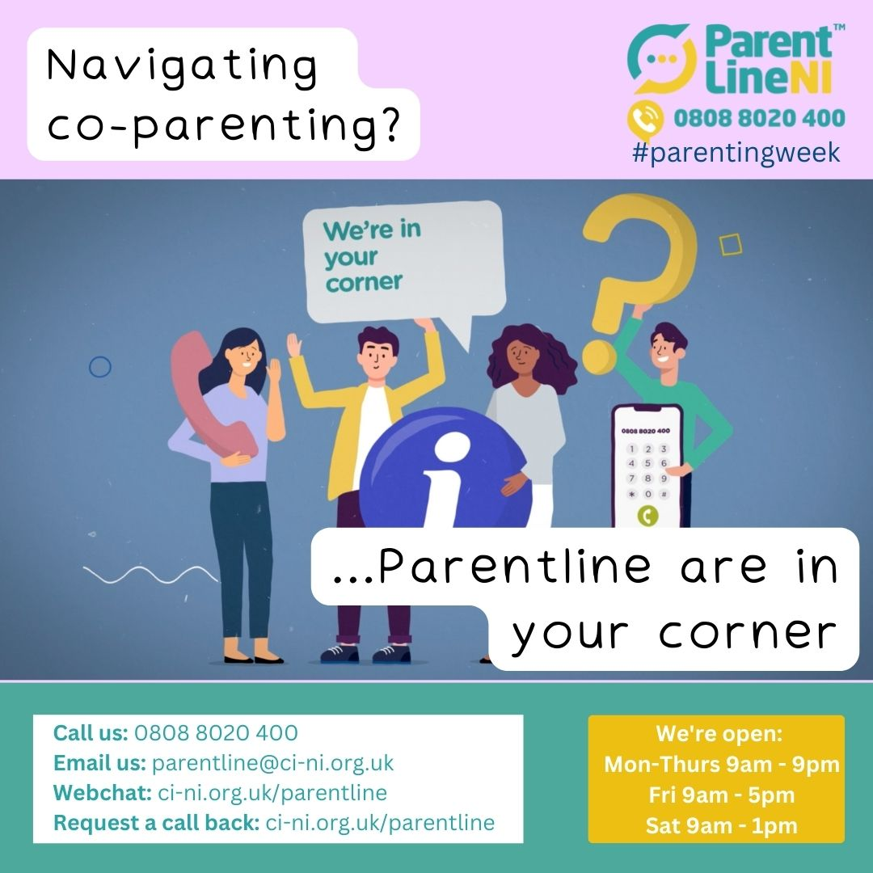

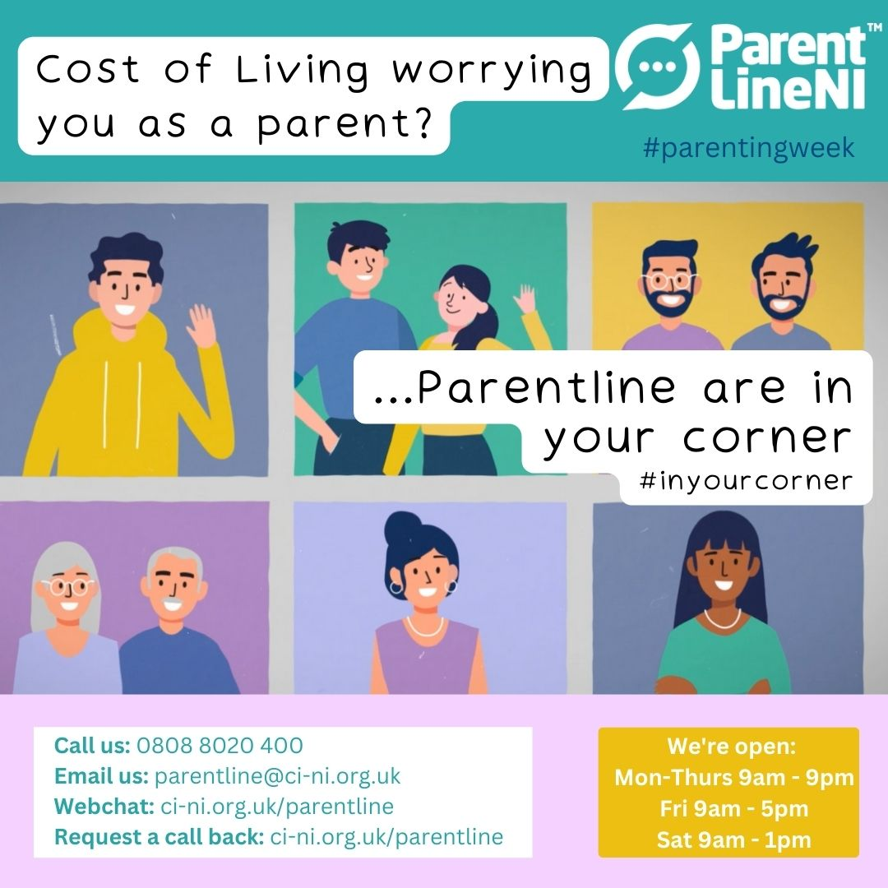

Post 5:
This #parentingweek, ParentlineNI are #inyourcorner. We’re here, to talk, today – there are no silly questions! Open 6 days a week, our local, highly experienced Parent Support Officers can listen to, support and guide you. It’s free and confidential. Call 0808 8020 400, we’re here for you.

Picture to go with post:

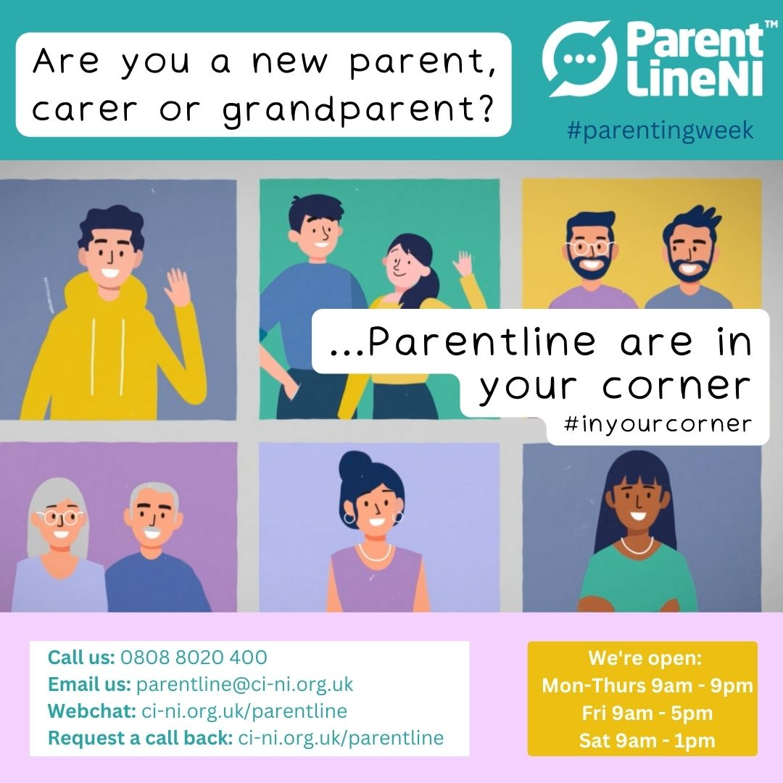

Post 6:
This #parentingweek, ParentlineNI are #inyourcorner, to talk about anything you are experiencing as a parent. There are no waiting lists, just a supportive, confidential space to help and support you. Call us today on 0808 8020 400, we’re available now to listen.

Picture to go with post: (one or more can be used)

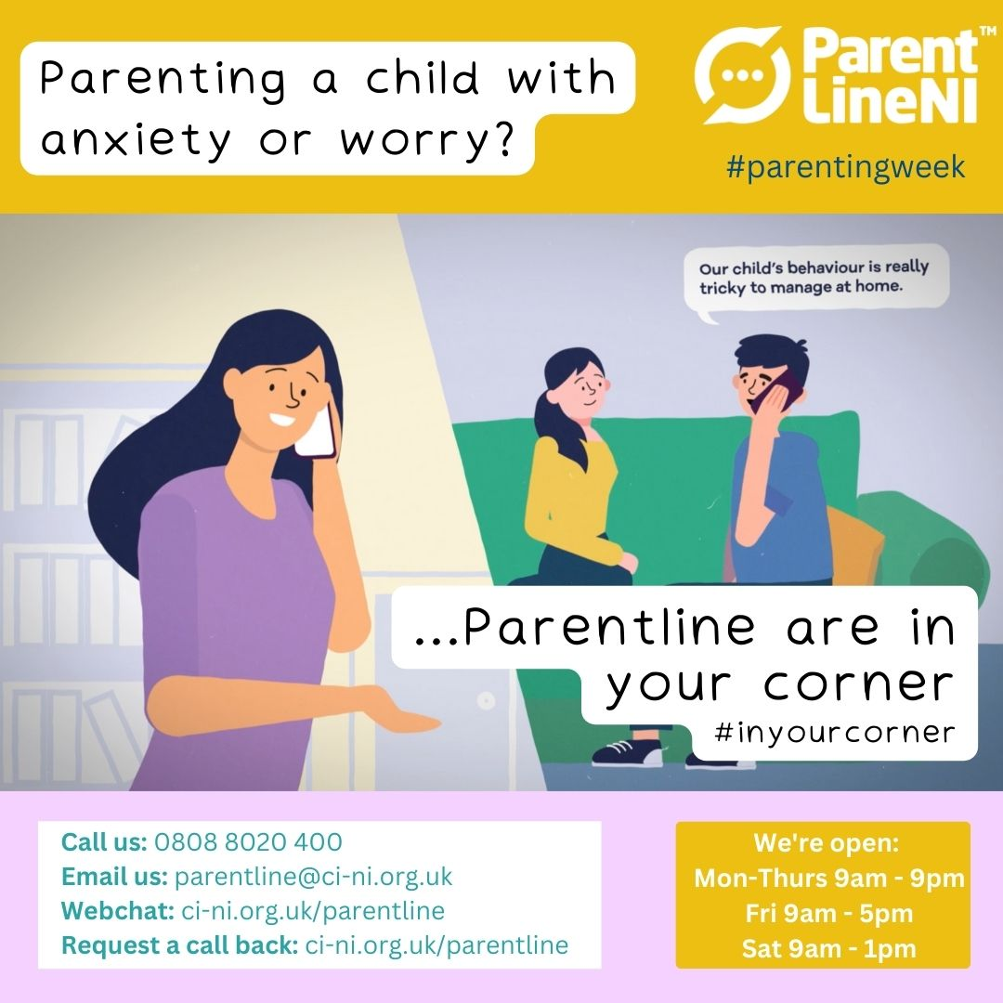

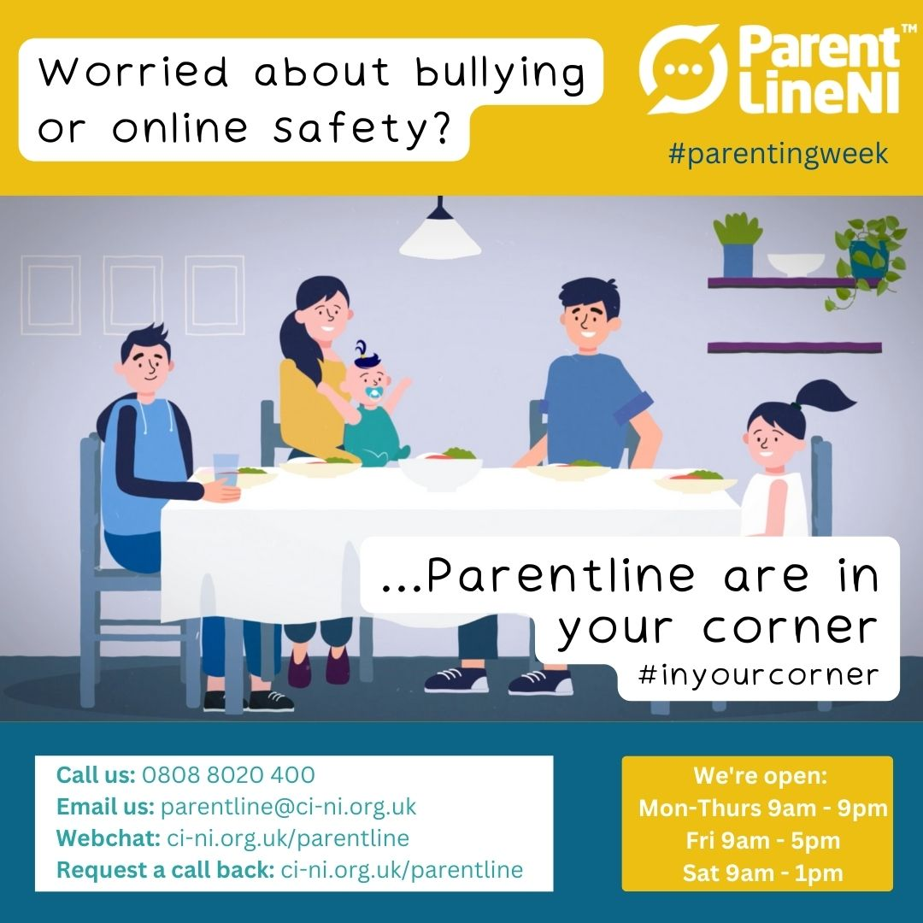

We hope you found these post ideas useful, and will get involved by scheduling some of them into your social media channels for Parenting week 2022, from October 17th-21st.

If you would like any more information/ resources, please contact Laurel Littlewood or visit our website: https://www.ci-ni.org.uk/parentline-resources/

Thank you for all your help in promoting our service during Parenting Week 2022.

