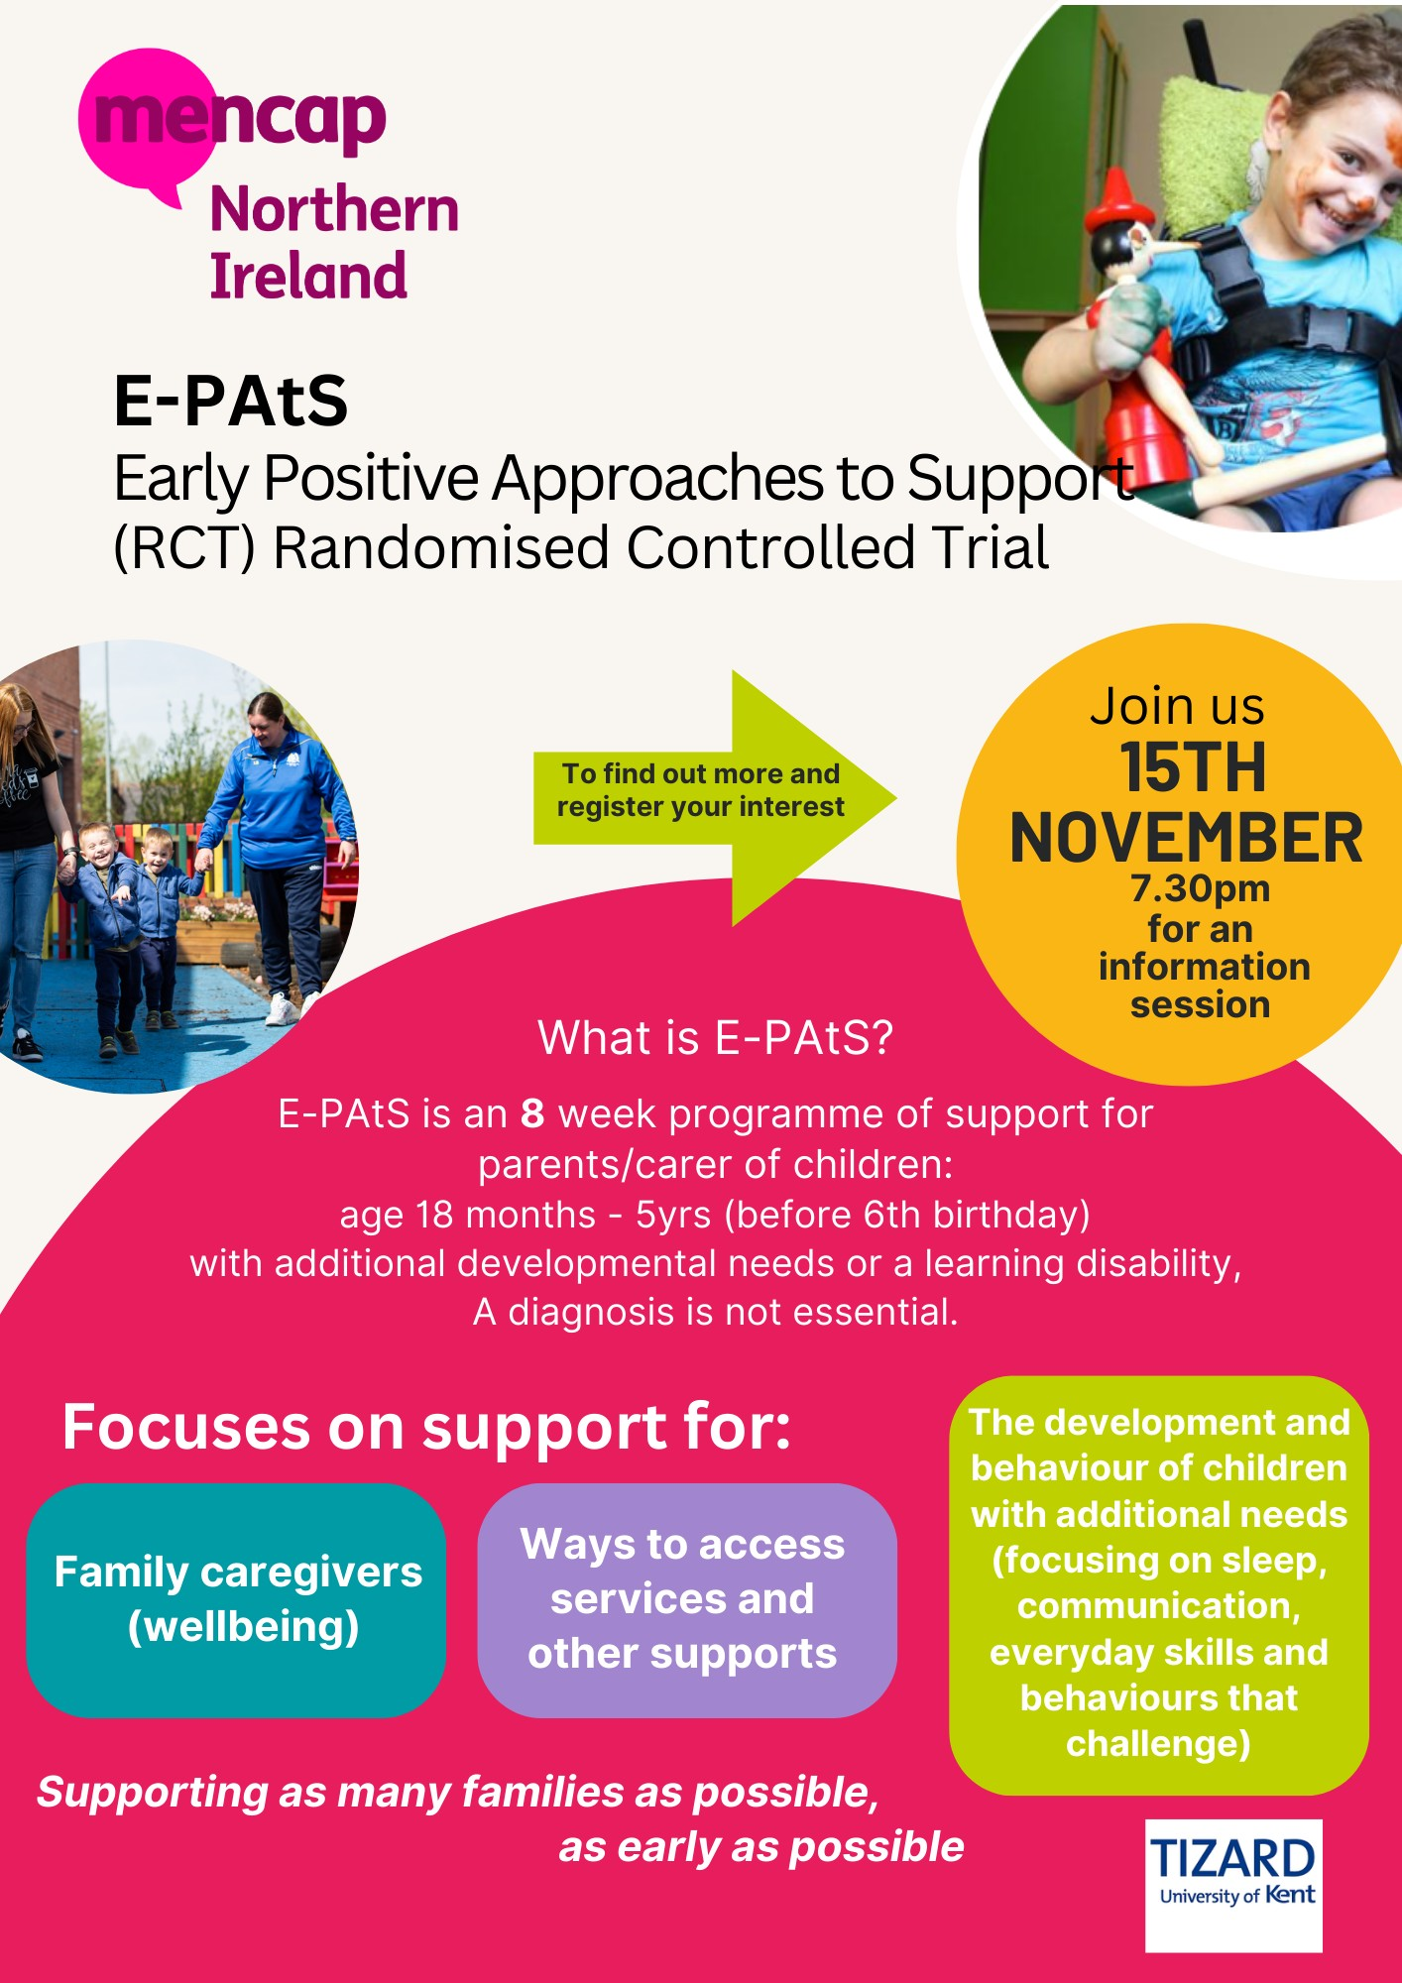

**Contact Lisa McGrath**

**Mencap Family Support Co-ordinator, Derry/ Strabane area**

[**Lisa.mcgrath@mencap.org.uk**](mailto:Lisa.mcgrath@mencap.org.uk) **or 07542392957**

**Pick the time that suits you best and use the links below!**

Monday 08/01/24 @ **8pm**

<https://shorturl.at/avNSZ>

Tuesday 09/01/24 @**1.00pm**

<https://shorturl.at/jzUY9>

Tuesday 09/01/24 @**7.30pm**

<https://shorturl.at/nsDX2>

**To find out more about E-PAtS in the DERRY/STRABANE area please contact LISA on 07542392957**

**Or**

**Join a short online information session:**